Tennessee Governor Bredesen’s Task Force on Energy Policy
Final Report: Executive Summary
Facilitator/Consultant Dr. Jonathan Raab, Raab Associates and MIT
February 2009
A. Task Force Process
On March 19, 2008, Governor Bredesen signed Executive Order Number 54, “An Order Establishing the Governor’s Task Force on Energy Policy.” The Order affirmed that “ensuring a clean, safe, reliable, and affordable energy supply is critical to the prosperity of the state economy, the sustainability of Tennessee’s environment, and the general welfare of Tennessee’s citizens.”

The goal of the Task Force process was to develop a state energy plan, including:

- Opportunities for state government to lead by example in energy efficiency and conservation, with an emphasis on building construction and management, and vehicle fleet purchasing and management;
- Prospective policies, legislation, regulations and/or incentives to encourage statewide energy efficiency and conservation in both the public and private sectors;
- Possible public-private partnerships and collaborations to encourage R&D of clean-energy technologies and to increase the potential for economic development in the state’s energy sector; and
- Strategies for expanding the use of alternative fuels and renewable energy sources to support the sustainability of Tennessee’s environment.

The Governor served as the chair of the Task Force, and appointed 16 additional representatives of state government, industry, academia, and non-governmental organizations.

Tennessee Governor’s Energy Task Force Members
Member Name | Affiliation
Honorable Phil Bredesen, Chair | Governor, State of Tennessee
Miles Burdine | Kingsport Chamber of Commerce
Phil Chamberlain | Home Builders Association of Tennessee
Dana Christensen | Oak Ridge National Laboratory
Commissioner Gwendolyn Davis | TN Department of General Services
Elizabeth Eason | United States Green Building Council
V. Lynn Evans | Memphis Light Gas and Water
Commissioner Jim Fyke | TN Department of Environment and Conservation
Commissioner Dave Goetz | TN Department of Finance and Administration
Jack Holder | Tennessee Valley Industrial Committee
Commissioner Matt Kisber | TN Department of Economic and Community Development
Kalee Kreider | Office of the Honorable Al Gore
Honorable Rosalind Kurita | Tennessee State Senate
John Noel | Southeast Alliance for Clean Energy
Emily Reynolds | Tennessee Valley Authority
Mike Vandenbergh | Vanderbilt University
Honorable Les Winningham | Tennessee State Legislature

The Task Force met seven times over eight months. The meetings took place throughout the state, but began and ended in Nashville, the state capital. These meetings included presentations by experts on a wide range of energy resource and policy issues. As the meetings progressed throughout the year, the Task Force also heard back from the three Work Groups established to educate the Task Force and provide recommendations. At the end of each Task Force meeting there was opportunity for public comment.
Task Force Meetings
Date | Location
May 5, 2008 | Nashville
June 6, 2008 | Chattanooga
July 16, 2008 | Kingsport
August 15, 2008 | Memphis
September 19, 2008 | Franklin
November 14, 2008 | Jackson
December 16, 2008 | Nashville

An integral part of the Task Force process was the Governor’s Summit on Clean Energy Technology, held October 14-15 at the Convention Center in Knoxville. This first-of-its-kind two-day Summit was attended by over 325 participants, and included presentations by more than 35 world-class leaders and experts.
The three Work Groups appointed by the Governor to develop recommendations for consideration by the entire Task Force were—

1) Lead-By-Example (for state buildings and fleets);
2) Residential Sector (homes and personal vehicles); and
3) Clean Energy Technology.

These Work Groups met numerous times, to analyze their respective challenges and opportunities, to comb the nation for best practices, and ultimately to develop recommendations specifically tailored for Tennessee. Each Work Group solicited presentations from national experts on topics central to their missions. In addition, Mike Vandenberg and Miles Burdine convened a day of public testimony in which representatives of over a dozen Tennessee businesses and NGOs spoke about residential and clean energy tech challenges and solutions. Dr. Jonathan Raab of Raab Associates, Ltd. and MIT facilitates the Work Group processes as well as providing technical assistance to the Work Groups, Task Force, and Governor.

Work Groups and Members
Work Groups | Members
Lead-by-Example | Noel (Chair), Kurita, Vandenbergh, Winningham
Residential | Vandenbergh (Chair), Chamberlin, Eason, Evans, Reynolds
Clean Energy Technology | Burdine (Chair), Christensen, Holder, Kisber, Kreider, Hoagland, Noel

The Work Group recommendations were accepted by the Governor and Task Force, and form the basis of this report. This executive summary presents a synopsis of the major findings and recommendations. (Greater detail about the work of the Task Force, as well as the findings and detailed recommendations of each Work Group can be found in the next chapters.)
B. Energy Use in Tennessee
Tennessee citizens, businesses, and government together spend over $20 billion per year on energy. The residential sector is the single largest consuming sector in Tennessee, representing 36% of the energy used, with industry following close behind at 34%. The remainder is used in commercial buildings (15%) and for non-residential transportation (15%).

Tennessee Total Energy Consumption by Sector, 2006
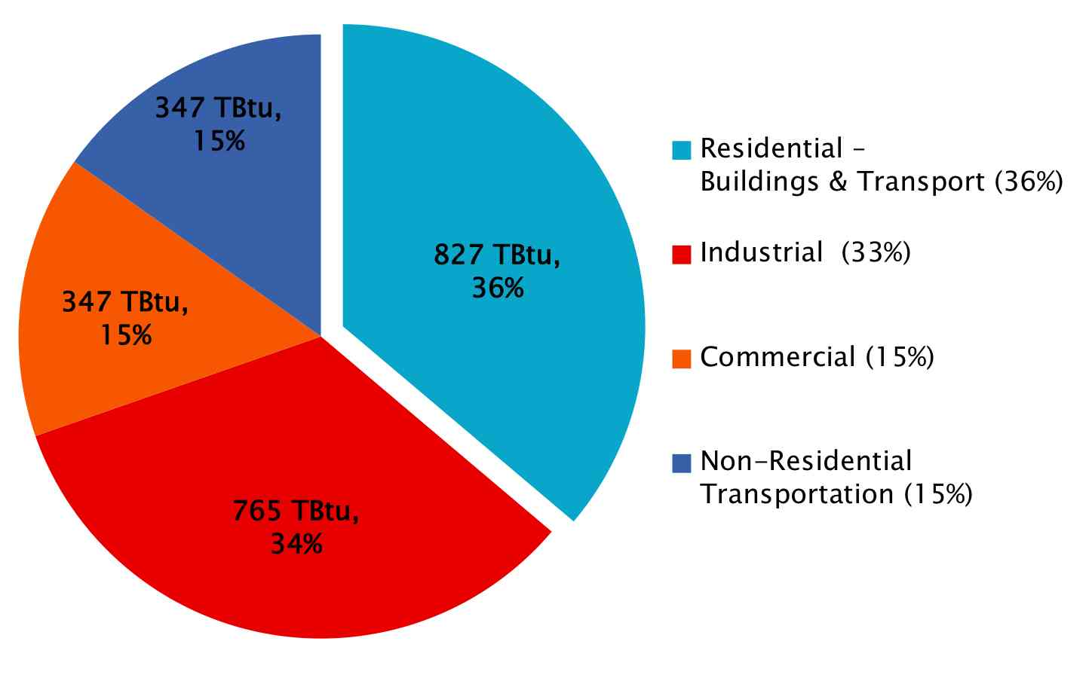
Figure compiled by F. Forster, Vanderbilt University, from EIA, BLS, DOT, and BTS data

Tennessee’s total energy use per capita ranks high compared to other states-- placing 16th out of all states in 2005 for energy use. With relatively low electric rates and high saturation of electric space heat, Tennessee’s 2005 residential electricity usage was the highest per capita of any state in the nation. As in most other states, residential electricity use per capita continues to rise annually in Tennessee. When factoring in consumption of all fuel types, Tennessee ranks right about average nationally for residential energy use per capita.

Residential Electricity Intensity by State, in MMbtu per capita (2005)
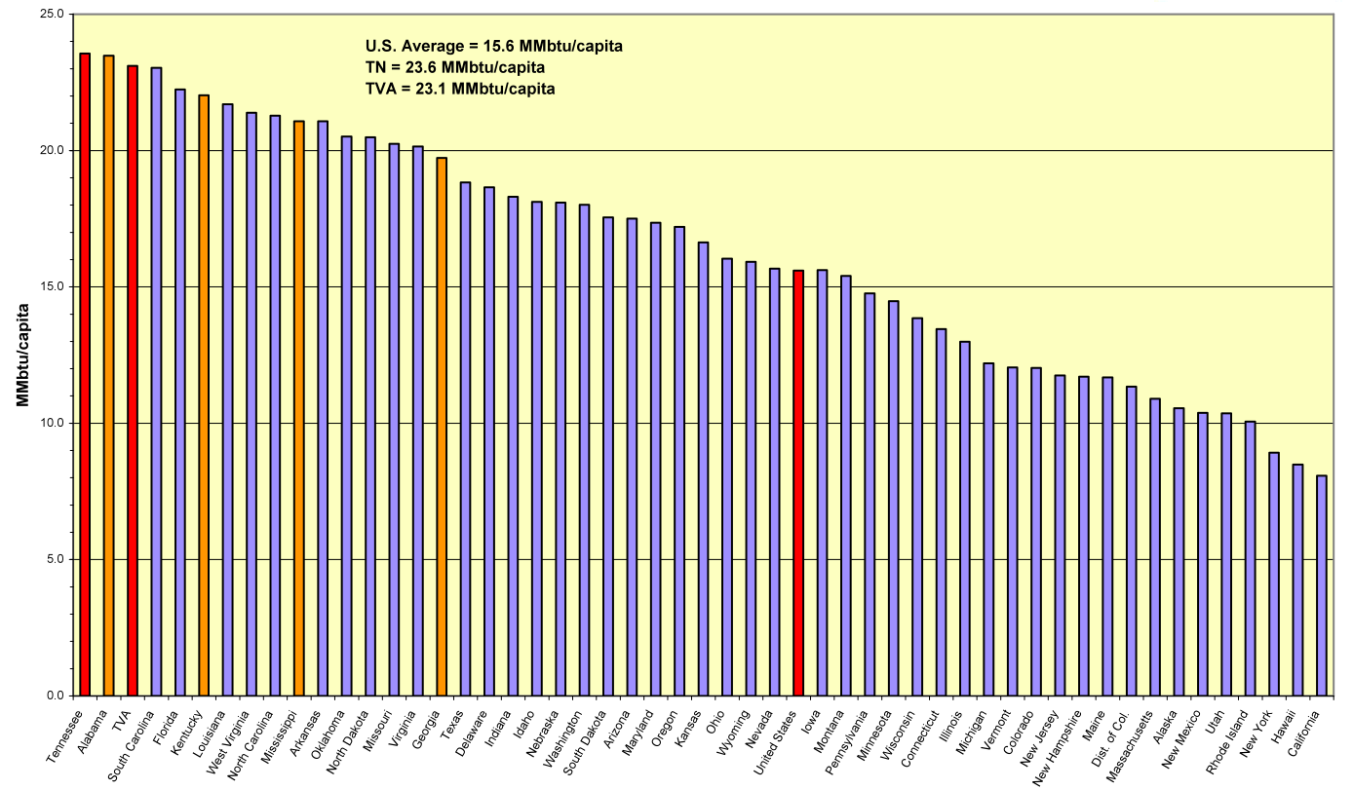
Source: TVA, from 2005 EIA data
Tennessee also ranks in the top ten in vehicle miles traveled per capita, which puts its gasoline consumption per capita above national average. However, unlike electricity consumption, which has been rising steadily each year, per capita gasoline consumption in Tennessee has stayed fairly steady.
Top Ten States for Most VMT per capita
Rank | State | Total VMT (millions) | Estimated Population | VMT per capita
1 | Wyoming | 9,058 | 509,294 | 17,1785
2 | Mississippi | 42,186 | 2,921,088 | 14,442
3 | Oklahoma | 47,019 | 3,547,884 | 13,253
4 | Alabama | 59,661 | 4,557,808 | 13,090
5 | Georgia | 113,509 | 9,072,576 | 12,511
6 | New Mexico | 23,966 | 1,928,384 | 12,428
7 | Vermont | 7,713 | 623,050 | 12,379
8 | Montana | 11,126 | 935,670 | 11,891
9 | North Dakota | 7,570 | 636,677 | 11,890
10 | Tennessee | 70,814 | 5,962,959 | 11,876
 | United States | 2,989,807 | 296,410,404 | 10,087

Source: US DOT/RITA/BTS, Table 5-3: Highway Vehicle Miles Traveled (VMT)

The state of Tennessee spent approximately $175 million for energy (electricity, gas, gasoline, propane) in 2007. Approximately $129 million was used to heat and cool, and to run the lights and equipment in state owned and leased buildings. The remainder was used to run the state motor vehicle fleet, and to reimburse employees for using their own vehicles. Given the steep rise in gasoline costs for most of 2008 and a recent increase of approximately 20% in electricity rates, Tennessee state government’s energy expenditures for 2008 likely exceeded $200 million, despite the recent economic downturn. Although this represents only about 1% of Tennessee’s total energy expenditure, it represents costs over which the state has direct control.

C. Leading-By-Example—Reducing Energy Use and Cost in State Building and Fleets
State Buildings

Tennessee owns or leases approximately 90 million square feet of buildings and facilities—divided roughly in thirds among General Government, The Board of Regents (TBR), and University of Tennessee (UT) campuses. Approximately 2/3 of the $129 million in energy dollars went to electricity, and 1/3 to non-electric heating costs. General Government accounts for nearly half the total building-related energy bill in 2007, with TBR and UT accounting for the other half.

Within General Government, 1/3 of the energy expenditures are overseen by the General Services Revolving Loan fund, while 2/3 are spread out over 25 separate departments and agencies. While all new construction, including energy-related features, passes through Finance and Administration, this is not true for energy-related retrofits (where the bulk of energy saving investments reside). Departments and agencies outside of the Revolving Fund, with varying degrees of in-house energy expertise, are free to decide whether or not to make energy efficiency investments at all, and to determine how to prioritize and fund such investments.
Moreover, although dollar expenditures for energy in state owned and leased buildings can be compiled, actual energy usage is not systematically tracked, reported and made readily available. Many buildings and facilities are not separately metered, making accurate tracking impossible. Lack of tracking of energy use at the building level makes it difficult to prioritize energy efficiency investment or to track progress once retrofits are in place.
Summary of Tennessee State Building Energy Costs, 2007
 | Electricity Costs (in millions) | Heating Costs | Total Energy Costs | % of Total
General Services Revolving Fund | $12.5 | $8.5 | $21.0 | (16%)
Other depts./ agencies (25) | $29.5 | $11.6 | $41.2 | (32%)
Total General Government | $42.0 | $20.1 | $62.2 | 48%
Total TBR & UT Systems | $45.2 | $21.7 | $66.9 | 52%
Total for State | $87.2 | $41.8 | $129.0 | 100%

Recommendations for state buildings cover both building that the state owns and occupies, and space the state leases. Recommendations address energy efficiency in new construction, major additions, and retrofitting of existing building, as well as increasing utilization of renewable energy resources and cogeneration.
- Existing State Buildings
  - Comprehensive Retrofits--Issue bonds to fund a 5-year, $85 million energy retrofit campaign in General Government buildings
  - Low-Cost/No-Cost Retrofit Measures and Operation Guidelines—Develop a short list of very cost effective measures (e.g., LED exits signs, CFLs) and energy saving guidelines (e.g., summer and winter temperature settings, lighting and conditioning during unoccupied hours) and implement in all buildings as soon as possible.
- New State Buildings and Major Renovation
  - Energy Standards—State Sustainability Guidelines should require that a new building’s energy performance meet at least the most recent IECC commercial energy code (allowing for no more than a two year lag from publication), and encourage 25% greater efficiency.

- For Both New and Existing Buildings
  - Energy Star--Immediately require ENERGY STAR labeled products (where available) for all new appliance and equipment purchases for use in state buildings and campuses. [Note: The Governor signed an executive order at the December 16th Task Force meeting implementing this recommendation.]

  - Cost-Effectiveness Metric--Utilize either longer payback periods than current 5-8 year Tennessee simple payback criteria, such as 15-20 years, or full life-cycle costing.
  - Renewable Energy and Cogeneration--Assess integrating renewable energy technologies (e.g., passive solar, solar water heating, photovoltaics, wind, and geothermal) in state buildings and utilizing cogeneration where feasible.
  - Building Energy Reduction Targets--Set a reduction target of total energy use in state buildings by an average of 15% by 2011 and 25% by 2013, as compared to 2007 usage (on a BTU per square foot basis).
  - Tracking, Reporting and Metering--Centrally track, benchmark, and report energy usage in all state buildings. Separately meter buildings to enable energy tracking at the building level.
  - Leased Space--Develop a comprehensive strategy for reducing energy use in state-leased buildings (i.e., 3.7 million of 9.4 million square feet in the Facilities Revolving Fund is leased space).
State Motor Vehicle Fleets
Tennessee owns approximately 10,000 vehicles, with 85% managed by General Services and the Tennessee Department of Transportation (DTOT) and 15% by UT and TBR. In 2007, these vehicles cost the state $22 million in fuel costs. The state spent an additional $27 million in 2007 to reimburse state employees who used their own motor vehicles at a flat rate of 50 cents/mile—a portion of this is to cover fuel costs.
Of the approximately 10,000 vehicles that the state owns, almost half are passenger vehicles. Fewer than 1% of these vehicles are compacts and none are “sub-compacts”. The state allows agencies to replace existing vehicles within a given size class automatically and, even within a vehicle class, does not systematically factor in relative mpg of vehicles when making purchasing decisions. No protocols are currently in place to take into account fuel costs when dispatching cars from the motor vehicle fleets, or to actively reduce the vehicle miles traveled (VMT) of state employees.
Tennessee Fleet Management: Breakdown of Passenger Vehicles by Class, 2007
Vehicle Class | General Services | % of GS Fleet | TDOT | % of TDOT Fleet | Total | % of Total
Compact Sedan | 10 | < 1% | 0 | - | 10 | < 1%
Mid-size Sedan | 536 | 15% | 244 | 27% | 780 | 18%
Large Sedan | 340 | 9% | 5 | < 1% | 345 | 8%
Van (mini- & full) | 726 | 21% | 112 | 13% | 838 | 19%
SUV | 586 | 17% | 67 | 8% | 653 | 15%
Pickup Truck | 1324 | 38% | 464 | 52% | 1788 | 40%
Totals | 3522 | 100% | 892 | 100% | 4414 | 100%

Tennessee Public Chapter 489, enacted in 2007, sets a 20% petroleum reduction target for state motor vehicle fleets by 2010. Nonetheless, there has been very little use of E85 in state vehicles. B20 fared only slightly better, despite increasing saturation of flex fuel vehicles and an increase of flex fuel pumps.
However, state vehicles are refueled using a “Fuelman” card which allows for easy tracking of energy usage, vehicle, and location (in contrast to state buildings where energy usage has not historically been tracked).
Recommendations for fleet management involve reducing the amount of fuel used (demand) and substituting preferable fuels (supply) for petroleum. Both vehicle efficiency improvements (reduced mpg) and VMT reduction can bring about a decrease in fuel use.
- Efficient Vehicle Purchases
  - Smaller Vehicles-- Expand state’s relatively small fleet of compact and sub-compact vehicles. Require departments and campuses to justify requests for any passenger vehicle larger than a compact.
  - Most Efficient in Class-- Increase state’s purchases of fuel efficient vehicles in every vehicle class, and fully incorporate fuel costs into new vehicle purchase decisions in every class using a “life cycle”- based method.
- Efficient Fleet Operation
  - Efficient Vehicle Dispatch--Require dispatch of the most efficient vehicles (lowest mpg) first from state motor vehicle pools.
  - Vehicle Maintenance--Require best practice maintenance schedules and techniques to minimize energy use in vehicle operation, including tires and tire pressure; vehicle tune ups; air filter and oil specifications; and maintenance schedules.
  - Improving Driving Efficiency--Educate state employees about inefficient driving practices such as unnecessary idling, excessive speeds, and uneven acceleration.
  - Reducing Vehicle Miles Traveled (VMT)--Require state departments and campuses to reduce VMT in state-owned vehicles and personal vehicle commuting through expanded use of technology (tele-commuting and video-conferencing), coordinated ride-sharing and van pooling, and mass transit.
  - Ensuring Use of Alternative Fuels--Require state employees to use E85 and B20 in flex fuel vehicles where available.
  - Energy Use in Personal Vehicles—Align state’s personal vehicle reimbursement policy with state’s energy reduction goals.
- Fleet Energy Reduction Targets
  - Targets--Meet the 2010 20% petroleum use reduction target established in Public Chapter 489, and establish 2015 targets of an additional 25% reduction in petroleum use in state fleets. Emphasize efficiency, down-sizing, and VMT reduction in addition to biofuels.
  - Monitoring and Reporting--Require a data-based monitoring system for state vehicles to ensure maximum compliance with vehicle related efficiency and alternative fuel policies and procedures.
D. Residential Sector Recommendations
Tennessee citizens spent over $10 billion per year on energy for their homes and vehicles. Approximately 63% of residential energy is consumed in buildings, 35% in personal vehicles, and 2% in mass transit and planes. The 63% used in buildings breaks down to 31% for space heating and cooling, 13% for appliances and electronics, 10% for water heating, 5% for lighting and 4% for refrigeration.
Tennessee Total Household Energy Consumption Estimates, by End-Use, 2006
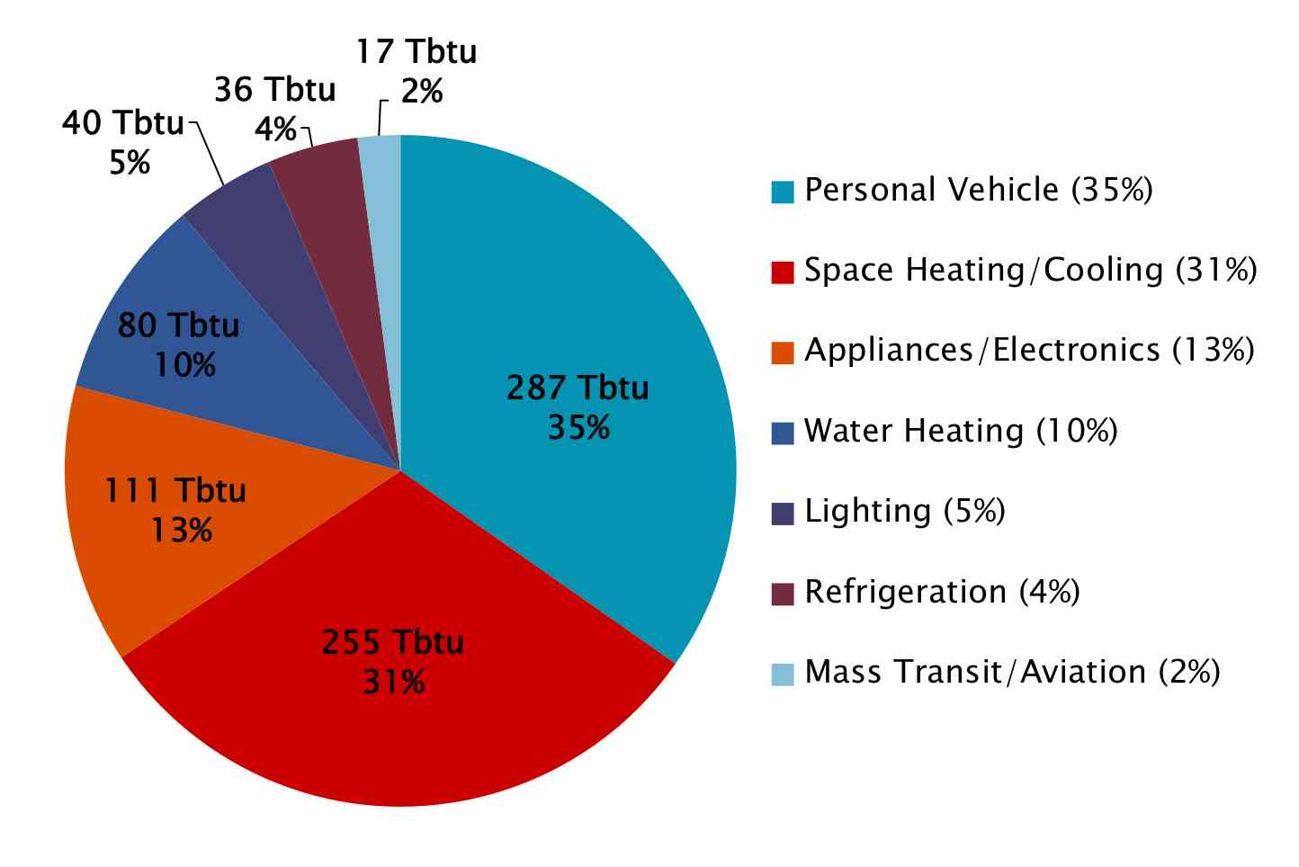
Figure compiled by F. Forster, Vanderbilt University, from EIA, BLS, DOT, and BTS data

Major improvements in residential energy use will require changes in how people use existing technologies (conservation) and the adoption of new technologies (efficiency and renewables). Experience and research demonstrate that well-designed public information and education programs, combined with new financial incentives and legal standards, can bring about significant changes in how energy is produced and consumed..
Recommendations for residential buildings and transportation fall into six categories 1) education and outreach; 2) building codes; 3) residential energy labeling; 4) natural gas efficiency; and 5) incentives for energy efficiency and renewable energy; and 6) personal vehicles and mass transportation
- Residential Energy Use Goal
  - Total residential energy use in Tennessee (including both buildings and cars – all fuels taken together) should be no higher than the 2007 usage by 2013 and then decline by at least 1% per year thereafter”
  - Regularly track and report residential energy use on both a total and per capita basis.

- Public Information and Education Campaigns
  - Public Information--Design and implement a public information campaign, including a website, on energy saving practices in residential buildings, and encourage energy distributors to develop a common information platform.
  - Efficient Driving and Maintenance Education—Join the EcoDriving Initiative started by the automobile manufacturers in association with national environmental groups. Promote the website and develop a plan to implement other supporting “state actions.”
  - Public Education--Update, improve and universally implement a graduated, multi-disciplinary state energy curriculum for K-12
- Building Codes
Tennessee began implementation of the International Energy Conservation Codes, version 2003, on January 1, 2009. However, Tennessee towns and cities are technically not required to enforce the IECC 2003 codes if they were not enforcing building codes previously.
- Updating Codes-- Automatically update residential energy codes to most recent IECC standards on a regular cycle beginning with 2009 standards, but allowup to two-year lag for full implementation.
- Enforcement and Compliance--Encourage and support local compliance and enforcement by assisting in the training of energy building code officials and trades, providing for “circuit riders” in counties that do not have energy code inspectors, and combining enforcement with HERS raters (see next recommendations on labeling).
- Home Rating and Labeling
Uniform rating and labeling of homes, similar to what is currently done for new cars and appliances, can be an effective way to convey information to homeowners and renters.
  - Label Design -- Labels should include HERS rating (normalized for house size), projected energy usage (total by fuel), and projected energy cost
  - Rating and Label Phase-In Schedule –Rating and labeling should be voluntary in 2009, and then required for new detached homes and major remodeling (>$25,000) in 2011. Rating and labeling should also be required, for existing housing prior to resale, when practicable; however, beginning in 2013 at least, require third party audit with recommendations and two years energy bills disclosure.

- Natural Gas Energy Efficiency Programs
Gas utilities in Tennessee should be offering a suite of ratepayer-funded gas energy efficiency programs for customers, similar to what TVA/distributors will be offering for electricity.
- Investor-Owned Utilities - IOUs covering about 1/3 TN residential gas sales in Tennessee and regulated by the TN Regulatory Authority should be required to spend around 1% of retail revenue annually on energy efficiency programs.
- Publicly-Owned Utilities - Publicly-owned gas companies not regulated by the Tennessee Regulatory Authority should be strongly encouraged to offer comparable gas efficiency programs
- Targeted Incentives for Efficiency and Renewables
Financial incentives should be developed to foster the installation of energy efficiency equipment and renewable energy products.
- Grant and Revolving Loan Program -- Develop a program to complement utility programs, targeting harder to reach sectors (e.g., low-income, rental housing, small business) and activities (e.g., equipment replacement, such as air conditioners especially at time of failure)
- Sales Tax Exemption – Develop a targeted ongoing sales tax exemption covering renewable energy applications (solar, wind, geothermal), select Energy Star products without mature market penetration (e.g., <50%), and potentially for advanced vehicles (e.g., plug-in hybrids).
- Other Innovative Financing Mechanisms - Explore other innovative finance mechanisms such as utility on-bill financing, and energy efficient mortgages tied to HERS rating.
- Residential Transportation Recommendations
Transportation (principally personal motor vehicles) comprises almost 40% of residential sector energy use, and large improvements in energy conservation and efficiency are achievable in these areas. For the transportation sector, changes in transportation-related behavior, vehicle efficiency, and infrastructure all can have a major impact on energy use.
- Driving Speed--Implement a three-prong approach to reducing driving speed including 1) public information campaign on the safety, energy and environmental benefits of speed reduction; 2) driver feedback through increased electronic speed-gauge signs and on-dashboard devices; and 3) increase speed limit enforcement.
- Commuting to Work – Support businesses (including state government) in developing VMT reduction policies and programs for employees (e.g. telecommuting, bicycling, transit, parking cash-out) through technical assistance, public education, and financial incentives.
- Public Transit-- Establish a dedicated annual transit funding source with guaranteed year-to-year adjustments. Allow urban counties to establish regional transit authorities with surrounding counties to raise local transit funding and better leverage federal transit funding. State employee IDs should be made into swipeable transit passes; and state should encourage similar program for large businesses.
- Smart Growth Commission – Establish a commission to develop recommendations on land use and infrastructure policies and practices that minimize energy use.
E. Growing Clean Energy Tech Jobs in Tennessee
Recommendations for growing clean energy technology related jobs in Tennessee fall into two broad categories. The first is “manufacturing” jobs generated from the production of clean energy related technologies, regardless of where those technologies are ultimately installed. The second is “installation and servicing” jobs created primarily through the installation of clean energy technologies within Tennessee.

Clean Energy Tech “Manufacturing” Job Recommendations
Sustainable Mobility—Tennessee is already poised to be an international leader in the sustainable mobility movement, which includes cellulosic biofuels, electric vehicles, and advanced diesel vehicles. Tennessee can build on this solid core to attract both other similar businesses, as well as businesses in other parts of the value chain.
Sustainable Electric System—Tennessee’s unique expertise in this area of growing importance in the U.S. currently lies primarily at ORNL, where its staff is engaged in federally funded research and demonstration on all of these topics. ORNL, TVA and its distributors, the University of Tennessee system, and Tennessee’s favorable business climate, could help to attract companies developing new hardware and software products to operationalize a sustainable electric system.
Where these circles intersect, there are numerous potential synergistic opportunities for creating businesses and jobs. Photovoltaics is one obvious place where the sustainable electric system and sustainable mobility industry (advanced batteries and smart meters are others) intersect. With Sharp’s existing PV module facility and Hemlock Semiconductor/Dow Corning’s December 2008 announcement of the opening of a new facility to manufacture silicon for PVs, a photovoltaics business cluster looks promising. There is a strong potential for businesses focusing on things like1) PV-assisted recharging Stations for electric vehicles; 2) battery storage for cars and PV arrays; and 3) smart grid hardware (such as advanced meters) and software to integrate PV and car recharging, and even V2G (vehicle-to-grid)
Strategy to Enhance Clean Energy Tech Manufacturing Business Recruitment and Expansion
- Augment Existing Economic Development Programs and Incentives—Tennessee is already viewed as a competitive and attractive state for clean energy tech manufacturing businesses , and currently offers a suite of economic development incentives -- both traditional (tax breaks) and innovative (absorbing carbon risk). To enhance these offerings, Tennessee should 1) classify the Clean Energy Tech sector as an “Emerging Industry” qualifying it for the Tennessee Jobs Credit among other benefits, and 2) work with TVA to create a new “Clean Energy Tech Manufacturer” designation that could allow TVA and other energy providers to make long-term commitments on pricing terms and provide other clean energy incentives.
- Provide Educated Citizenry and Trained Work-Force—An educated and well trained workforce is essential for fostering clean energy tech manufacturing jobs (and installation and servicing jobs) in Tennessee. Tennessee can improve its trained workforce through 1) certificate-based training at community colleges; 2) improving basic math and science skills and an understanding of energy issues and technologies in general education; and 3) expanding free, public education to years 13 and14, with a focus on Clean Energy Tech and supporting trades.
- Develop a Center for Applied Clean Energy Tech RD&D, Demonstration Projects, and Clean Tech Business Development—Tennessee, ORNL, TVA, and major corporations should form a center focused on applied clean energy tech RD&D. This endeavor could pull together federal, state, ratepayer and corporate funds into clean energy tech investigations and demonstration projects of common interest.
- Make Tennessee Citizens and Businesses Leaders in the Sustainable Mobility and Sustainable Electric System Movements—Clean energy tech manufacturing companies generally like to locate in states friendly to clean energy technologies, and Tennessee should utilize the products of its clean energy tech manufacturers. This requires that Tennessee adopt policies and programs that result in citizens and businesses incorporating more energy efficiency and renewable energy technologies in their homes, offices, and factories, as well as investing in the necessary infrastructure to facilitate adoption of clean energy technologies.
Clean Energy Tech “Installation and Servicing” Job Recommendations
Tennessee can accelerate the adoption and use of clean energy technologies in the state through education and information campaigns, targeted financial incentives, and regulation. This will generate a substantial number of Tennessee jobs in the installation and servicing sectors, as well as attract clean energy tech manufacturing facilities.
- Build on and Enhance Existing Tennessee Clean Energy Tech Related Initiatives for Businesses—Tennessee already has a suite of incentive based promote the installation of clean energy technologies at businesses (including Small Business Energy Loan Program, Green Energy Tax Credit, and Clean Energy Technology Grant Program). These preexisting incentive programs should be fine-tuned and enhanced in light of other new initiatives offered by electric and gas utilities, or federal and local governments.
- Implement Residential and Lead By Example Work Group Recommendations-- Most of the recommendations delineated in the Residential and LBE chapters of this report will result in expanding clean energy tech installation and service jobs in Tennessee, such as from capturing energy efficiency and renewable energy opportunities in new construction and the retrofitting of existing buildings.
- Electric Vehicle Recharging Infrastructure—Tennessee should develop recharging infrastructure to facilitate electric vehicle use in the state including: A) installing electric vehicle recharging at park-and ride lots and public parking; B) expanding Green Corridors program to include rapid electric recharging; and C) requiring proper outlets in new homes through building codes
- Smart Meters and Time-Sensitive Pricing--In anticipation of universal installation of smart meters and implementation of “time-sensitive” pricing, Tennessee can facilitate the development of necessary communications networks (i.e., web connection in every home.)
- Siting--Streamline and expedite siting and permitting for renewables, combined heat and power, and efficient buildings. Use dedicated TDEC/TECD “Energy Team” to help developers navigate state and local processes, and consider establishing “fast track” zones in certain parts of the state for specific resources.
- Interconnection Standards--Encourage the development of interconnection standards for customer-sited renewables and distributed generation. Specifically, the state should work with TVA and distributors to facilitate feasible and equitable standards.
- Renewable Portfolio Standard—Although Tennessee does not directly regulate TVA or its distributors, it should seek a voluntary RPS agreement with TVA that requires increasing percentages of electricity to come from renewable energy resources, or encourage federal RPS requirements.
- Clean Vehicle Fuel Standard –Tennessee should consider implementing a clean vehicles fuel standard that encourages lower greenhouse gas intensity fuels.
F. State Leadership and Staffing
Tennessee businesses and citizens are spending over $20 billion/year on energy. Around 1% or $200 million of that total is spent by the state for energy used in its buildings and motor vehicle fleets. The recommendations in this report, if implemented, will reduce energy usage, expenditures and emissions—while substantially growing clean energy tech jobs. To be successful, however, Tennessee will need ongoing state involvement to properly design and implement the recommendations in this report for citizens, businesses, and especially for state government. Strong, highly visible leadership in state government and adequate staffing is essential for not only implementing the recommendations in this report but developing the next generation of policies and programs. One immediate need for Tennessee’s energy leadership and staff is the Federal Stimulus Package. Tennessee, to the extent it has discretion, should work to direct clean energy tech related stimulus dollars to support the initiatives recommended by this report.

Over 20 states are already implementing the IECC 2006 code.
Recharging infrastructure should be PV-assisted where feasible

